 | OFFICE OF RESEARCH

Build Your OSP Budget with Claude
Draft a complete Office of Sponsored Programs budget by describing your project in plain language.
1 GATHER › |  | 2 INSTALL › |  | 3 DESCRIBE › |  | 4 HAND OFF

1 GATHER WHAT YOU HAVE  Claude builds from whatever you can tell it. Rough answers are fine, and the budget gets more accurate as you add detail.   Opportunity link — the web address of the funding announcement   Who is involved — names, and roughly how much time each person will spend   Start date and length — when the project begins and how many years it runs   Anything else you have — a draft scope of work, vendor quotes, or a subaward budget |  | 2 INSTALL THE SKILL  The skill is published on GitHub. You download it once, add it to Claude, and it stays in your account.  1. Go to github.com/duncan-brown/research-skills. Open dist › su-osp-budget › highest version number.  2. Click the file, then click Download raw file, the download icon at the top right.  3. In Claude: Customize › Skills › + › Create skill › Upload a skill, then choose the file you downloaded.  No account yet? its.syr.edu/getclaude  Stuck? resdev@syr.edu
3 DESCRIBE YOUR PROJECT  Open a new chat and set the model to Opus. The skill needs Opus to calculate correctly. Begin your first message with “Use the OSP Budget skill,” then describe the project in ordinary sentences.  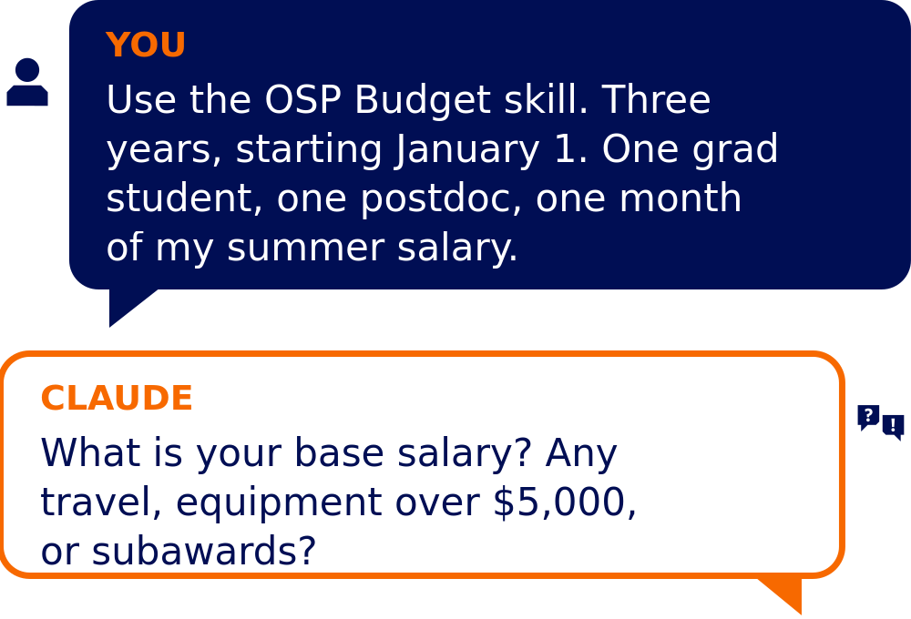  Claude asks follow-up questions until it has what it needs. Answer what you know, say “I do not know yet” for the rest, and revise at any point. |  | 4 HAND OFF THE FILE  Claude populates the OSP Budget Workbook and gives you an Excel file to download and share.  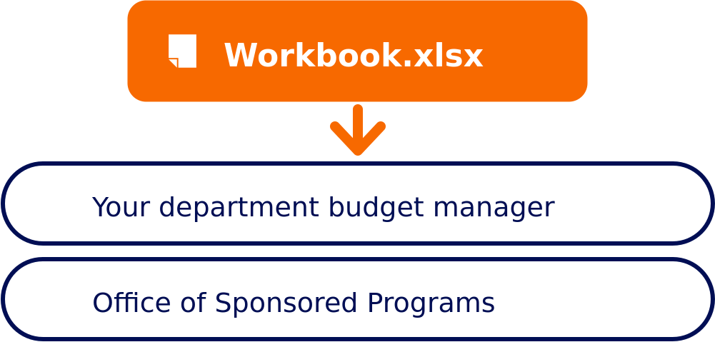  This is a strong starting draft, not a final submission. The Office of Sponsored Programs verifies rates, allowability, and sponsor compliance, and submits the proposal.
Office of Research · Questions? resdev@syr.edu · research.syracuse.edu

