Syracuse University Limited Submission Standard Operating Procedure
Category | SOP
Author | Office of Research
Date Created | August 2020
Last Updated | August 2026

Overview
A Limited Submission Opportunity (LSO) is a funding opportunity in which the sponsor sets an institutional limit on the number of proposals it will accept. These opportunities may be from federal sponsors, state sponsors, corporations, or foundations. In order to participate in an LSO, Syracuse University must organize to submit our most competitive proposal(s). This requires an internal competition, institutional review, and when applicable, a panel review. The Office of Research (OoR) manages and facilitates LSOs for Syracuse University. This process document serves as guidance to ensure a stronger chance of awards being granted, as well as prevent the submission of more proposals than allowed, which would possibly lead to the rejection of all proposals from Syracuse University. This process typically does not include opportunities which are limited at the individual principal investigator (PI) or department level. This process does not address any student programs unless they are submitted through the Office of Sponsored Programs with the student as PI.

Procedure

OoR Identification of LSOs
OoR will list LSOs on the Syracuse University Application Portal (InfoReady) and post each LSO to the OoR Limited Submission webpage. OoR may also email LSOs directly to faculty in cases where eligibility is restricted to a small group. Additionally, active LSOs will be included in the monthly OoR Newsletter. If you do not currently receive the newsletter, please email vpr@syr.edu to request your addition to the distribution list.

Internal Competitions
There are two types of internal competitions: a Letter of Intent (LOI) or a Proposal. An LOI is a brief expression of interest — typically requirements are a title and abstract. A proposal requires a full set of application materials, such as a project summary, CV/biosketch, and budget. Faculty may apply to more than one internal competition at a time, as each opportunity is reviewed independently.

I. Letter of Intent (LOI)
Internal competitions for letters of intent (LOIs) are run to gauge faculty interest in a particular funding opportunity. At this stage, only submission of a title and project abstract is required to express interest in the opportunity. Additional eligibility information may be collected (e.g. start date, application track).
If the number of LOIs submitted by the internal deadline matches or is fewer than the number allowed by the sponsor, applicants will be permitted to move forward with a submission to the sponsor, pending institutional review.
If the number of LOIs submitted by the internal deadline exceeds the number allowed by the sponsor (e.g., four faculty have expressed interest in applying to an opportunity where the sponsor only allows one proposal from the University), we will announce an internal competition for proposals.

II. Proposal
Internal competitions with proposals will be announced when the number of LOIs submitted exceeds the maximum allowable amount, the LSO has been historically competitive (e.g. National Science Foundation Major Research Instrumentation Program), or has a very short timeline. Proposal materials vary by LSO and are designed to align closely with the sponsor’s solicitation. Standard materials include, but are not limited to:
- Brief project summary (2-5 pages).
- Biosketch or CV of PI (format noted in each competition).
- Budget estimate (in a format designated in the competition; does not need review by the Office of Sponsored Programs).
- Other materials specific to the requirements of the sponsoring agency or the opportunity, which may or may not be required, such as:
  - Confirmation from the appropriate dean(s) and chair(s) of commitment to cost share (copies of email correspondence are acceptable).
  - Past reviews
If the number of proposals submitted by the internal deadline exceeds the number allowed by the sponsor, panel review will be triggered.

Review Process

I. Panel Review
Under the panel review process, proposals will be evaluated by an internal ad hoc committee established by OoR. Panel review members will be asked to evaluate and provide comments on the proposals according to the LSO criteria and may also meet to discuss a final panel recommendation. The panel will aim to determine which proposal(s) will have the best chance of success in external competition and will also consider which proposal(s) are best aligned with the University’s strategic goals. Panel members are encouraged to provide written feedback to be shared with applicants. Every attempt is made to ensure that panel deliberations and final decisions are completed in a timely manner, thereby optimizing the time available to the awardee(s) for preparation of their application to the funding opportunity. Reviewers will be asked to score submissions according to the LSO criteria, while considering the following:
- Responsiveness to the guidelines set forth in the funding opportunity announcement;
- The competitiveness of the PI or PI’s team, including funding record with the agency;
- The likelihood of receiving funding;
- The manner in which a proposal answers or overcomes previously identified deficiencies if submitted in a prior cycle.
In some cases where specialized knowledge is needed, external reviewers may be consulted.
The panel review panel recommendations are provided to the Vice President for Research (VPR) for final decision.

II. Institutional Review
LOIs and proposals are always initially reviewed by OoR for compliance when submitted. The VPR makes the final decision on whether an applicant (or in the case of no internal competition, the first party to express interest) will be permitted to apply to the sponsor.

III. Notification
Notifications for internal competitions are made through InfoReady. When applicable, panel review feedback will be shared with the applicant. If not selected to move forward with a submission, a PI may apply to the same LSO in a future cycle, provided they continue to meet the eligibility criteria at the time of the new submission.

Nominations
In the case of internal competitions that require the University to nominate an applicant (ex. Pew Scholars Program, G. Harold and Leila Y. Mathers Foundation), OoR, in consultation with the review committee and the VPR, reserves the right to not select a nominee for the program. Where relevant, OoR will consult Foundation Relations (FR) for funder-specific and relationship considerations.

Foundation Opportunities
OoR will coordinate with FR for internal competitions to Foundations, as FR can provide funder-specific knowledge to applicants.

“Slots” Remaining After Internal Competition
If the number of LOIs or proposals submitted by the internal deadline is fewer than the number allowed by the sponsor, remaining "slots" will become “first come, first served”. At this stage, eligible applicants may express interest in the opportunity at any time before the sponsor deadline and will be permitted to submit to the sponsor pending institutional review. If this is a nomination-based opportunity, OoR, in consultation with the VPR, reserves the right not to select a nominee for the program. (see Nominations).
LSOs for which the internal deadline has passed, but “slots” remain are listed on our Limited Submission webpage and in the Office of Research Newsletter. Please email LimitedSubmissions@syr.edu to express your interest in these LSOs.
In the case of an approved “first come, first served” applicant, we may request the applicant submit a title and abstract to the posted InfoReady competition for recordkeeping.
See Appendix #1 for a schematic of this process.

PI Identification of LSOs
If a PI is interested in applying to an opportunity that is not posted in InfoReady and the Limited Submissions webpage, please email the solicitation details to LimitedSubmissions@syr.edu. OoR staff will evaluate the solicitation and determine how to proceed.
The interested PI will be permitted to obtain approval for a submission to the sponsor without OoR running an internal competition if:
- OoR received notification of the PI's interest less than 45 days before the sponsor deadline;
- the sponsor has publicly posted the opportunity for at least two weeks;
- an internal review by OoR reveals no additional interested parties; and
- institutional review permits the applicant to move forward with a submission.
If this LSO is a nomination-based opportunity, OoR, in consultation with the VPR, reserves the right to not select a nominee for the program. (see Nominations).
See Appendix #2 for a schematic of this process.

Timeline
To provide ample time for proposal preparation, OoR aims to post internal competitions for letters of intent twelve or more weeks prior to sponsor deadline and eight to ten weeks prior to sponsor deadline for proposals.
Some limited submissions may be released by the funder with very quick turnarounds (less than six weeks), particularly for any specialized governmental funding. These LSOs will be classified as internal competitions, but the internal deadline to submit will be approximately one week after public posting of the opportunity.
For some highly competitive opportunities or those which are anticipated to have a quick turnaround, OoR may post the internal competition in InfoReady before the sponsor has released the solicitation. This is noted in the InfoReady posting and is updated once the solicitation becomes available.

Special Cases

Institutionally Coordinated Opportunities
Internal competitions may be run for some highly competitive opportunities that are not LSOs to coordinate applications across the institution and ensure alignment of applications with the sponsor's priorities. These competitions are categorized as an “Institutionally Coordinated Opportunity” in InfoReady and are still managed by OoR.

PI Responsibilities
Awarded PIs and their teams must agree to the following responsibilities:
- Notify OoR within five business days of selection notice if a proposal is selected and the PI or team decides to forgo an application. This allows another proposal to be selected and move forward.
- If the PI fails to submit a proposal and has not notified the OoR, the PI runs the risk of being disqualified from future LSO competitions.
- If the proposal is submitted and not funded, the PI may be asked to share feedback received from the sponsor with OoR, including summary statements and peer and sponsor review comments. This information may be helpful in the selection process for future proposals for that LSO.
- For any sponsored research projects, the applicant must be eligible to serve as Principal Investigator for the project, unless otherwise noted in the LSO. Please see our PI Eligibility requirements to ensure you are eligible.

Need Help?
If you have questions about this process, contact OoR at LimitedSubmissions@syr.edu.

Revision History
Version | Date | Author | Summary of Change
1.0 | August 27, 2020 | OoR | Initial version.
1.1 | August 4, 2026 | OoR | Migrated to standardized SOP template; revised formatting and expanded on process.

Appendix

Schematic of LSO Process – OoR Identification of LSO

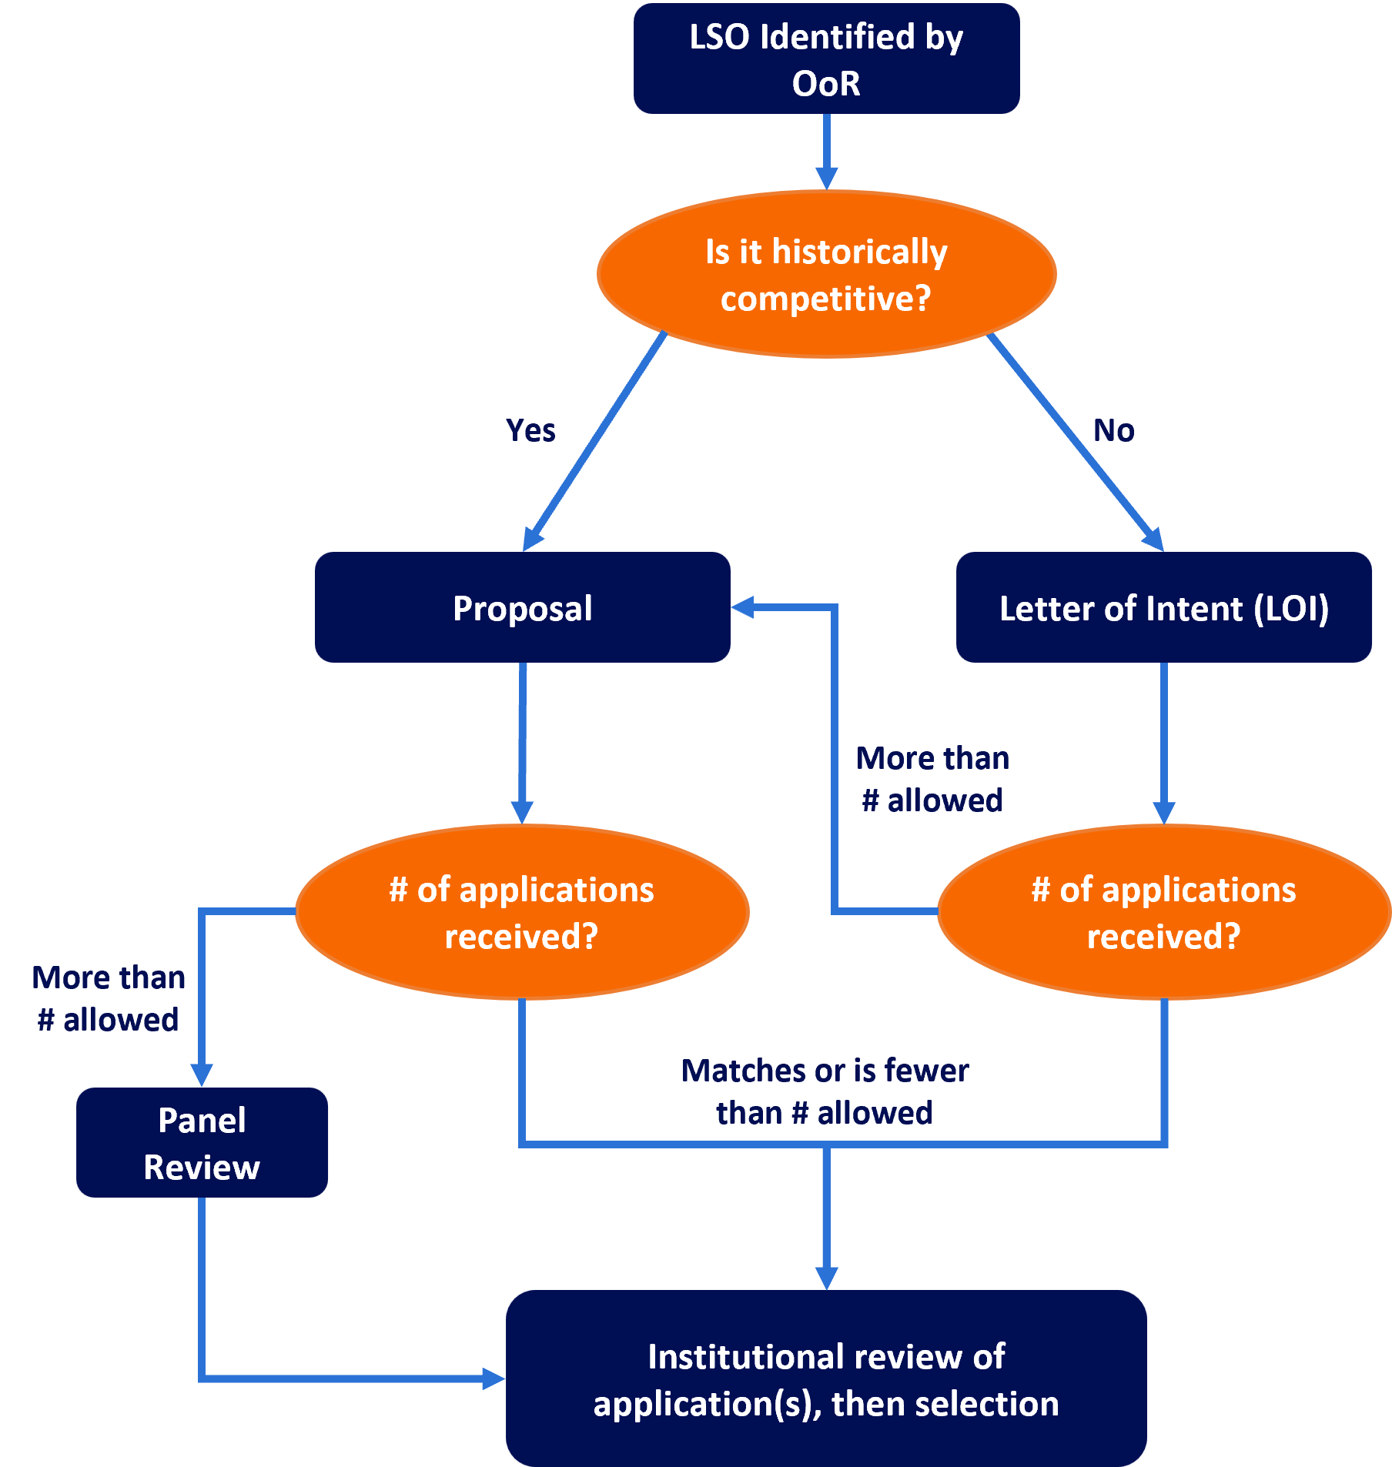

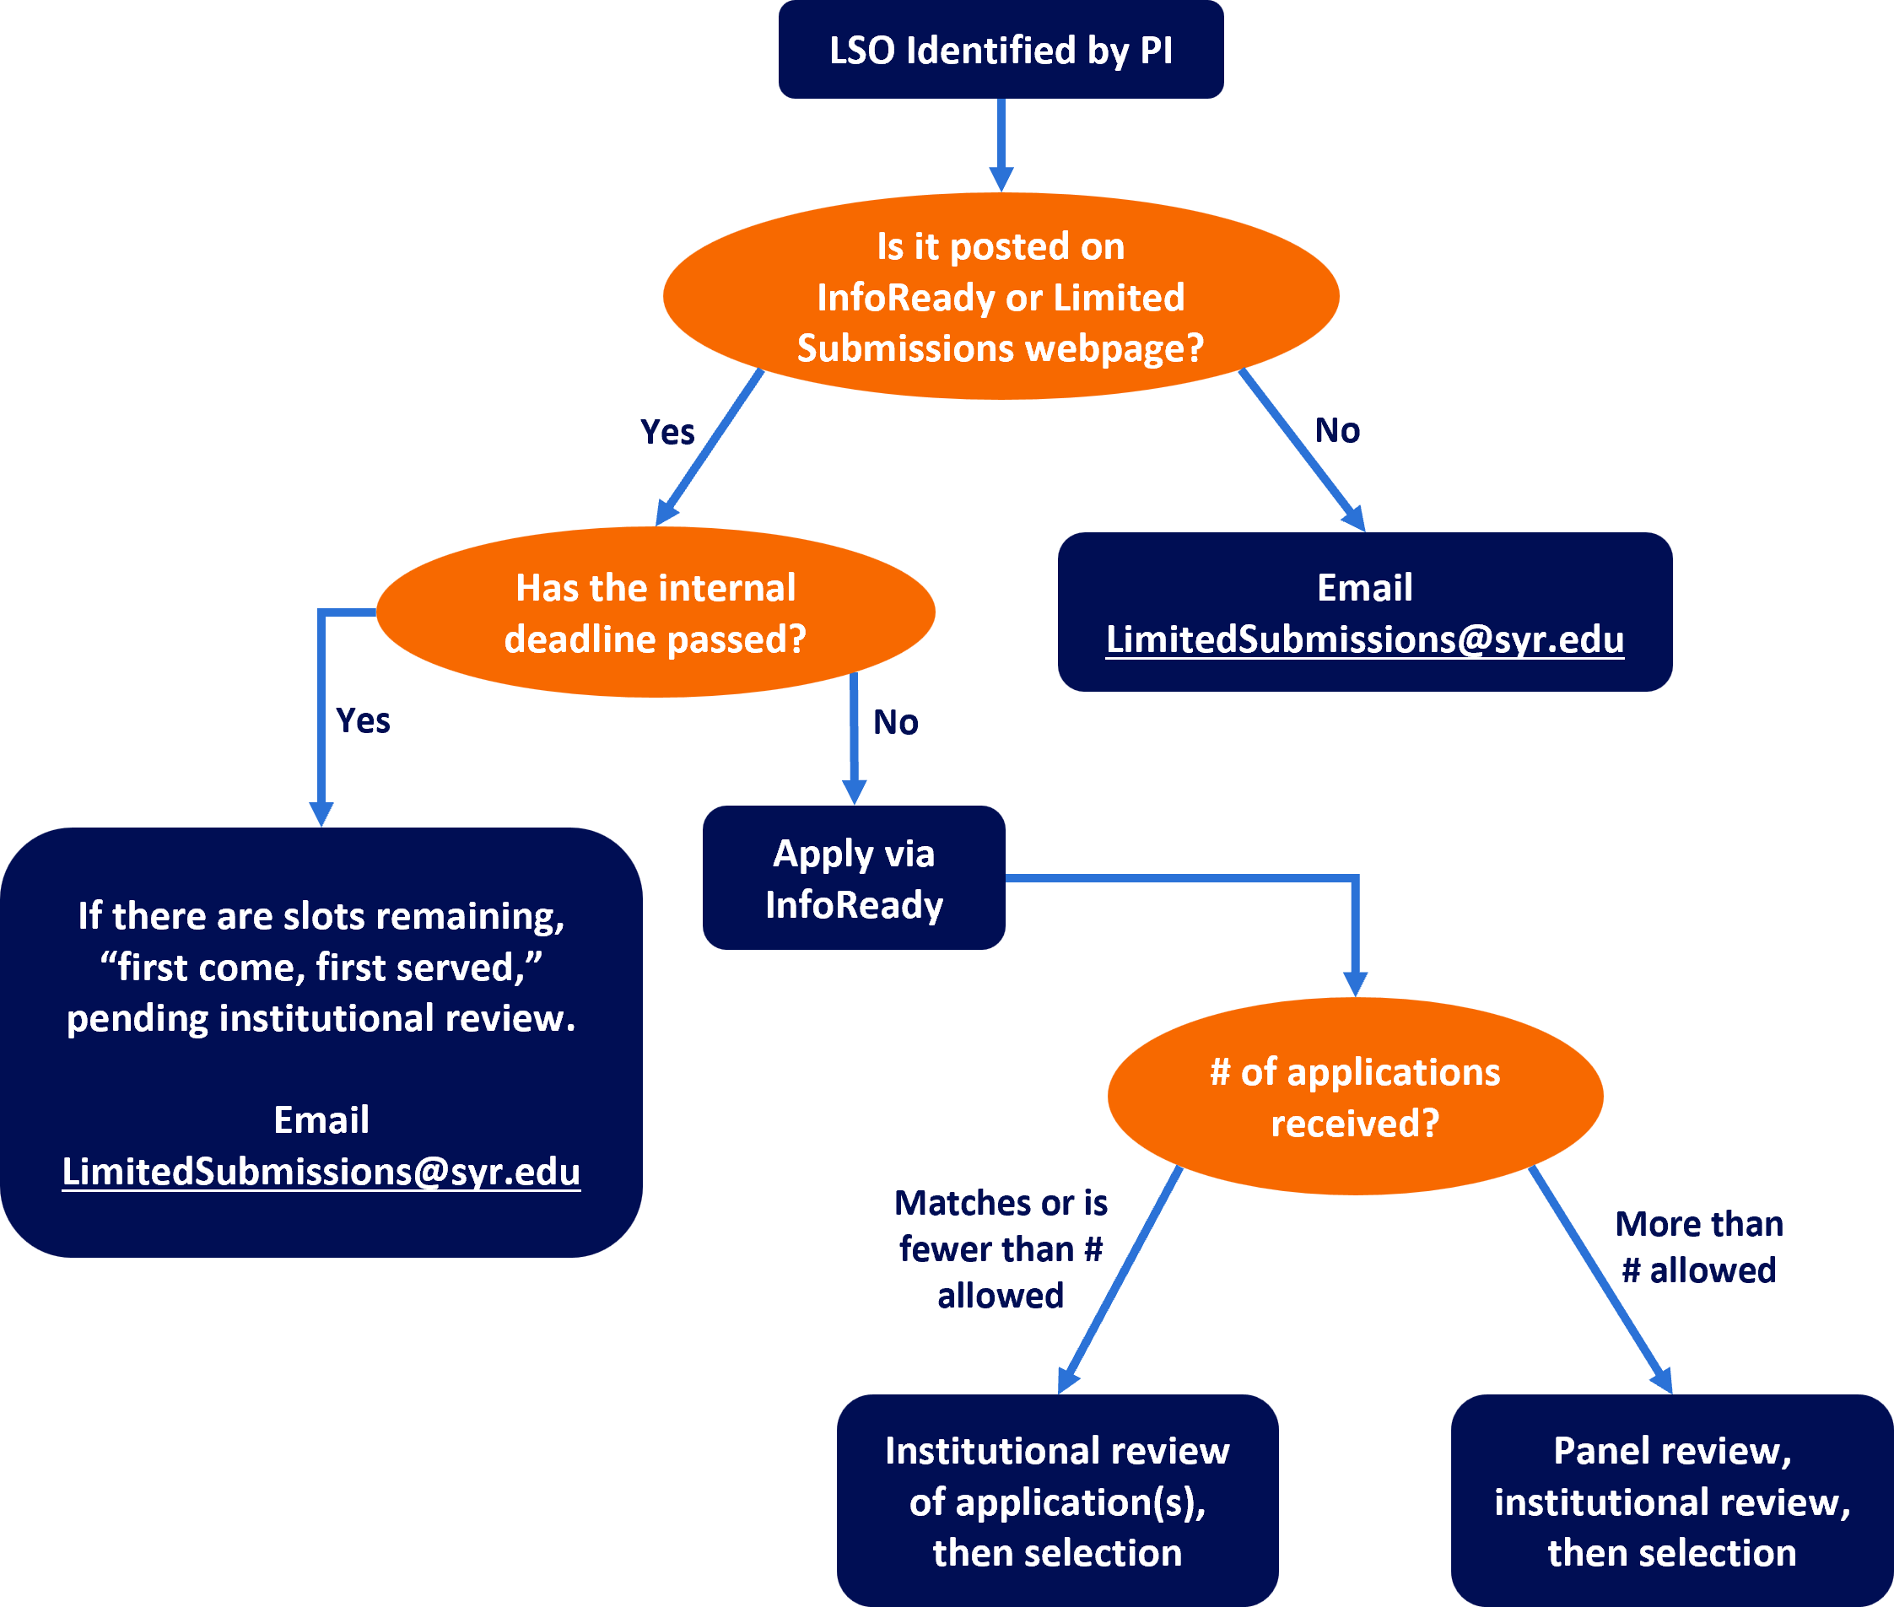
Schematic of LSO Process – PI Identification of LSO

